|  |  |  |
| --- | --- | --- |
|  | **Rochester Institute of Technology**  **Golisano College of Computing and Information Sciences**  **School of Interactive Games and Media**  **2145 Golisano Hall – (585) 475-7680** |  |

**Data Structures & Algorithms for Games & Simulation II**

**IGME 309**

**E09: Projections**

This exercise follows lecture Projections

It is meant to help you practice the use of glm library’s projection and view methods.

There is starter code for this project, you will find it under our class repository with the name E06s_Projections but if you want to use your own framework you are welcome to translate the starting code to it.

Once you open the solution you will be presented with the following scene:

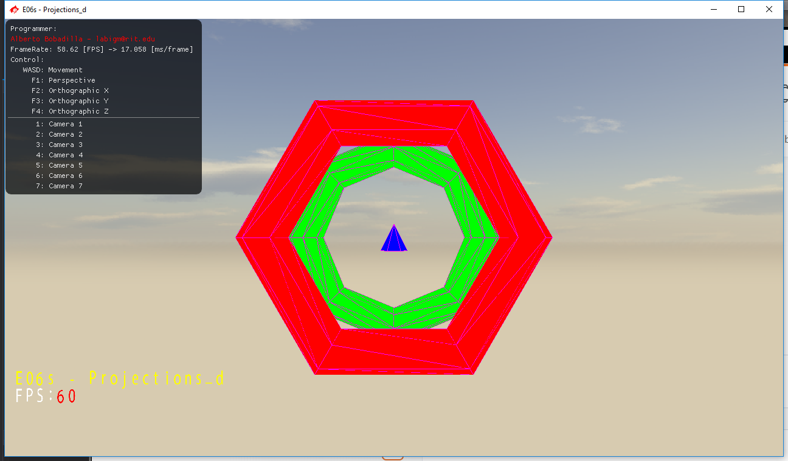

This is the original scene and the default one when you reset the camera. The point of this exercise is change the arguments to the projection and view functions in the camera pointer to recreate the following scenes:

Scene 2:

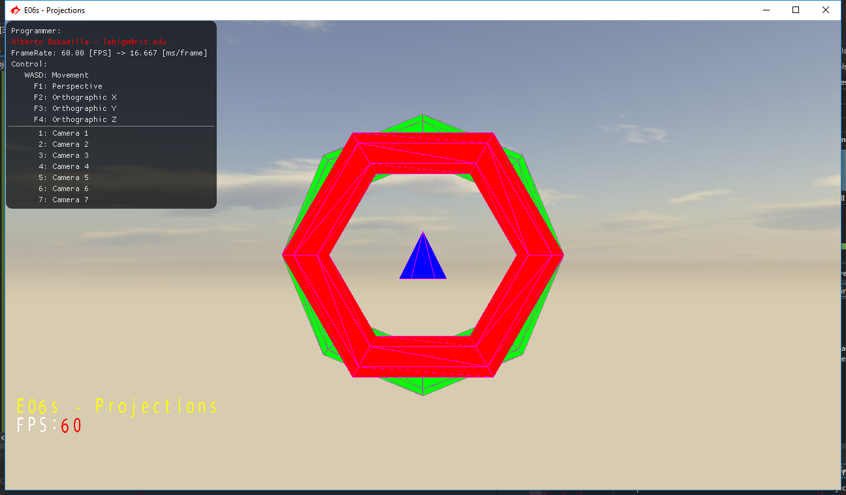

Scene 3:

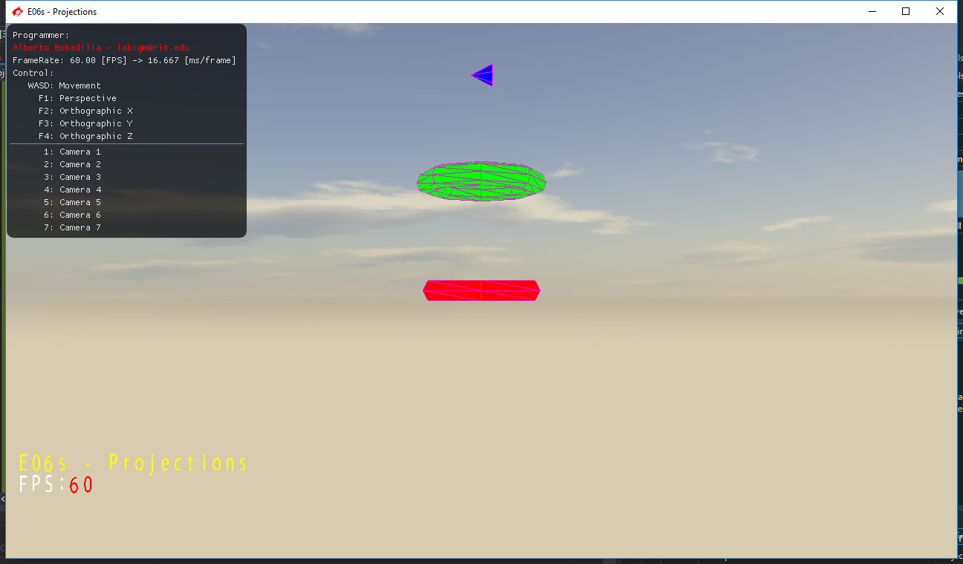

Scene 4:

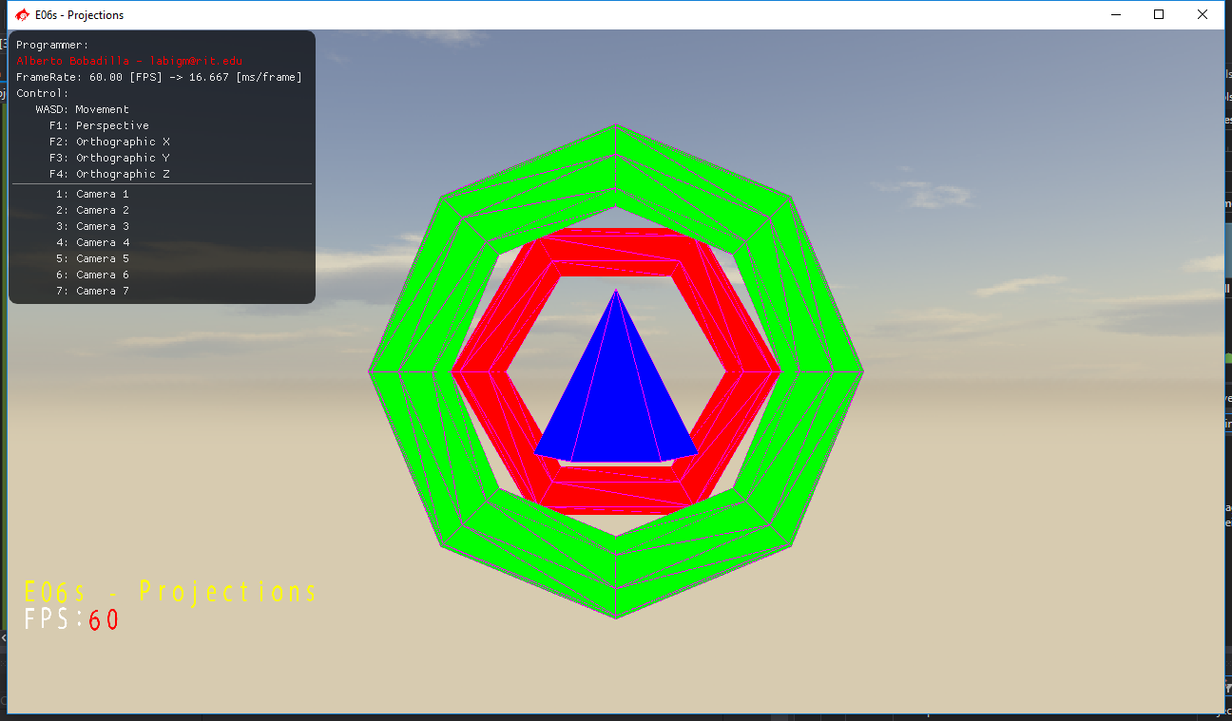

Scene 5:

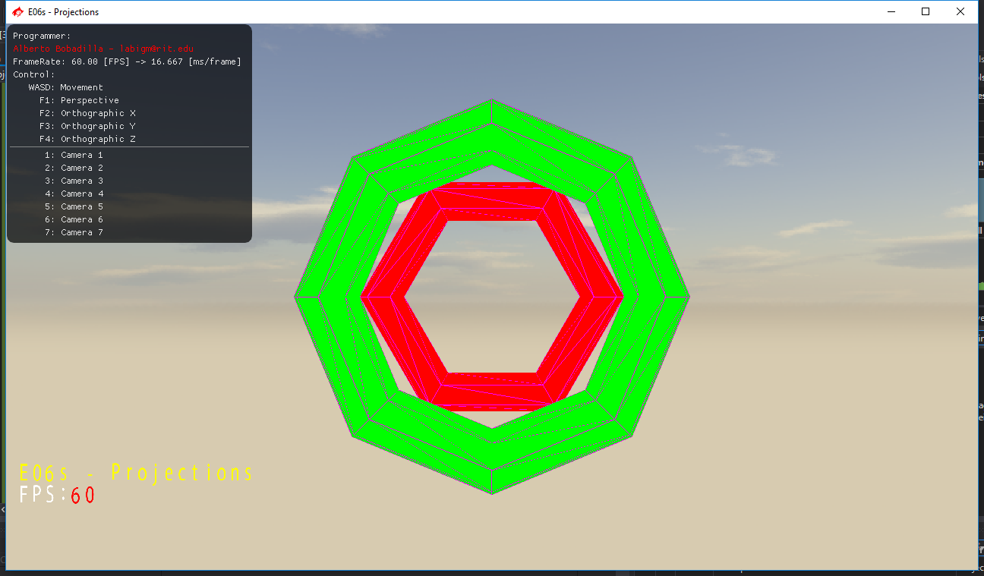

Scene 6:

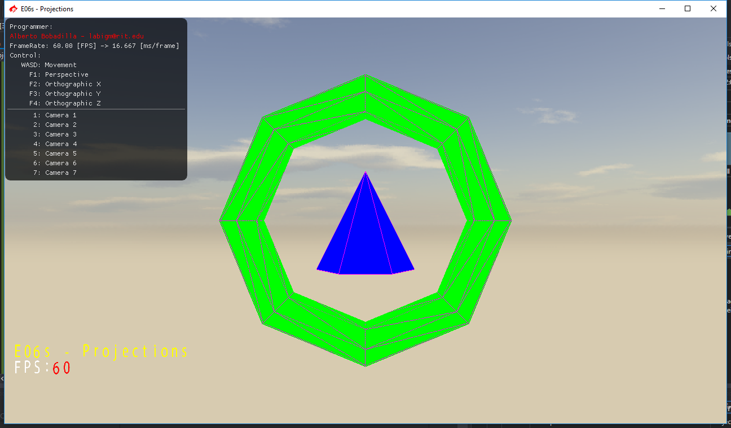

Scene 7:

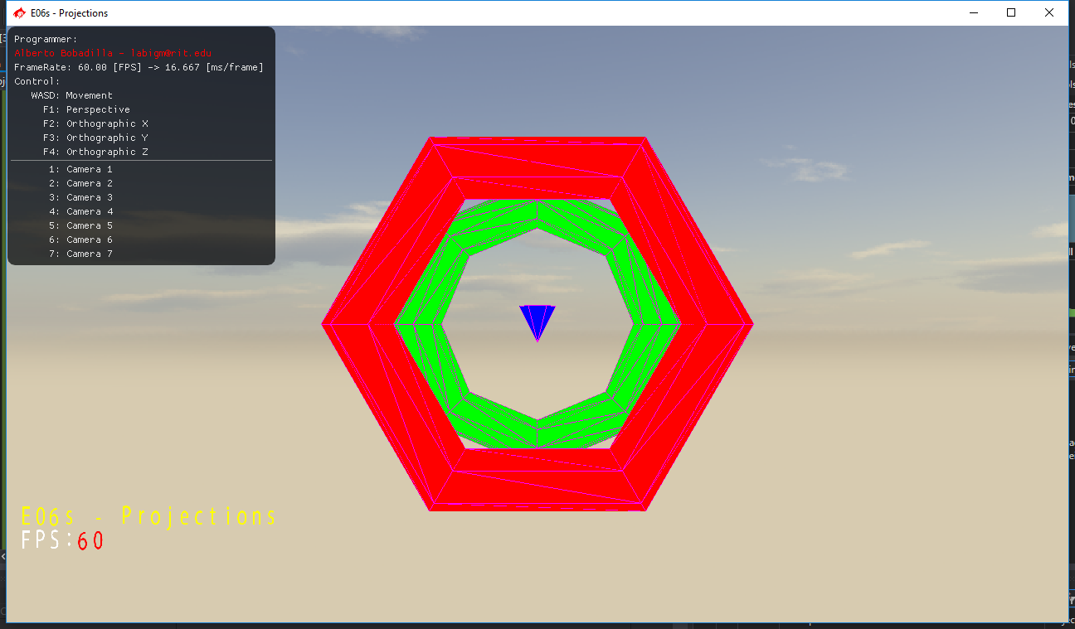

Feel free to add more scenes if you want.

The way the camera’s view and projection is setup in this exercise is very inefficient, it is meant only to make the exercise easier for you, if you want to translate modify the code so it only changes the view and projection once you press the button and not each frame.

I recommend you reset the camera each attempt before modifying your scene that way you warranty that you are starting with the default values.

You are not allowed to modify the model matrix of the primitives in any way.

Notes:

As usual, your submission is only a zipped version of the project NOT the whole solution, it should be less than 50 kb total, (unless you are using your own models/textures or your own framework solution). Push your solution to your repository with the comment “**E06 Deliverable**” then zip the project and upload it to the dropbox “**E09 - Projections**”, in the comments section you need to specify the address of your repository.

Example:

